Assignment 2:
Badshah Jan (2280175)
BSSE-7B
LAB 2b:
Manage Governance via Azure Policy:
TASK 1:
Create Resource group with Tags:
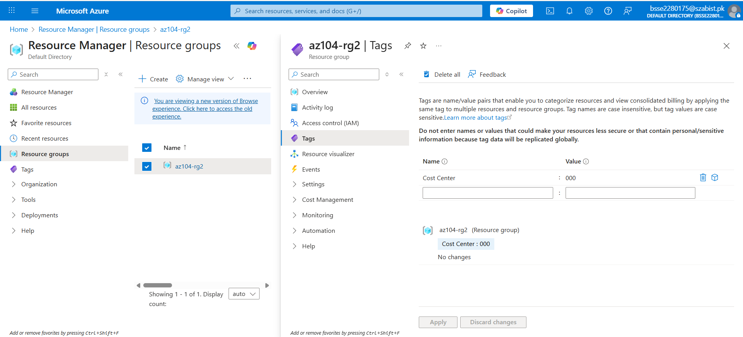

TASK 2:
Policy – Tag Enforce:
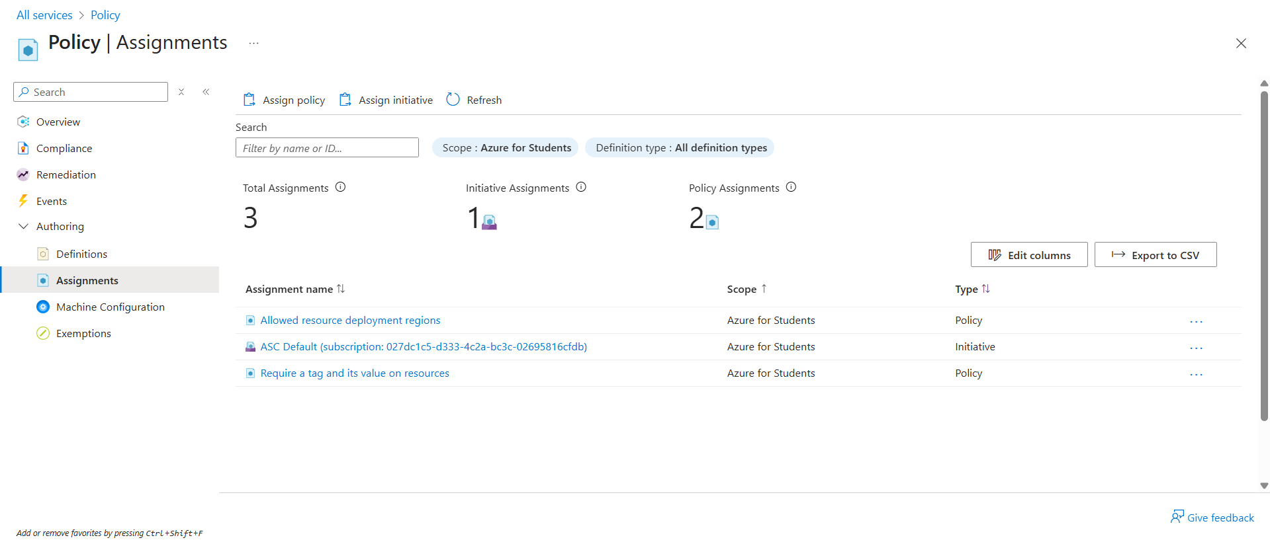

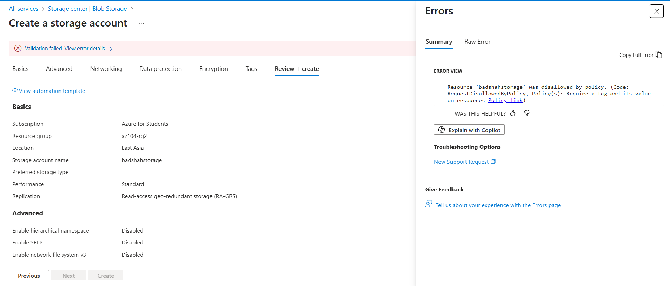

TASK 3:
POLICY – INHERIT TAG (SUCCESS TEST):
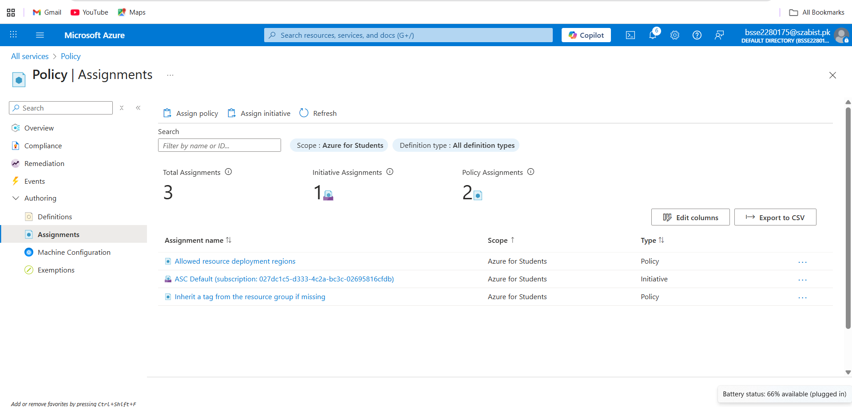
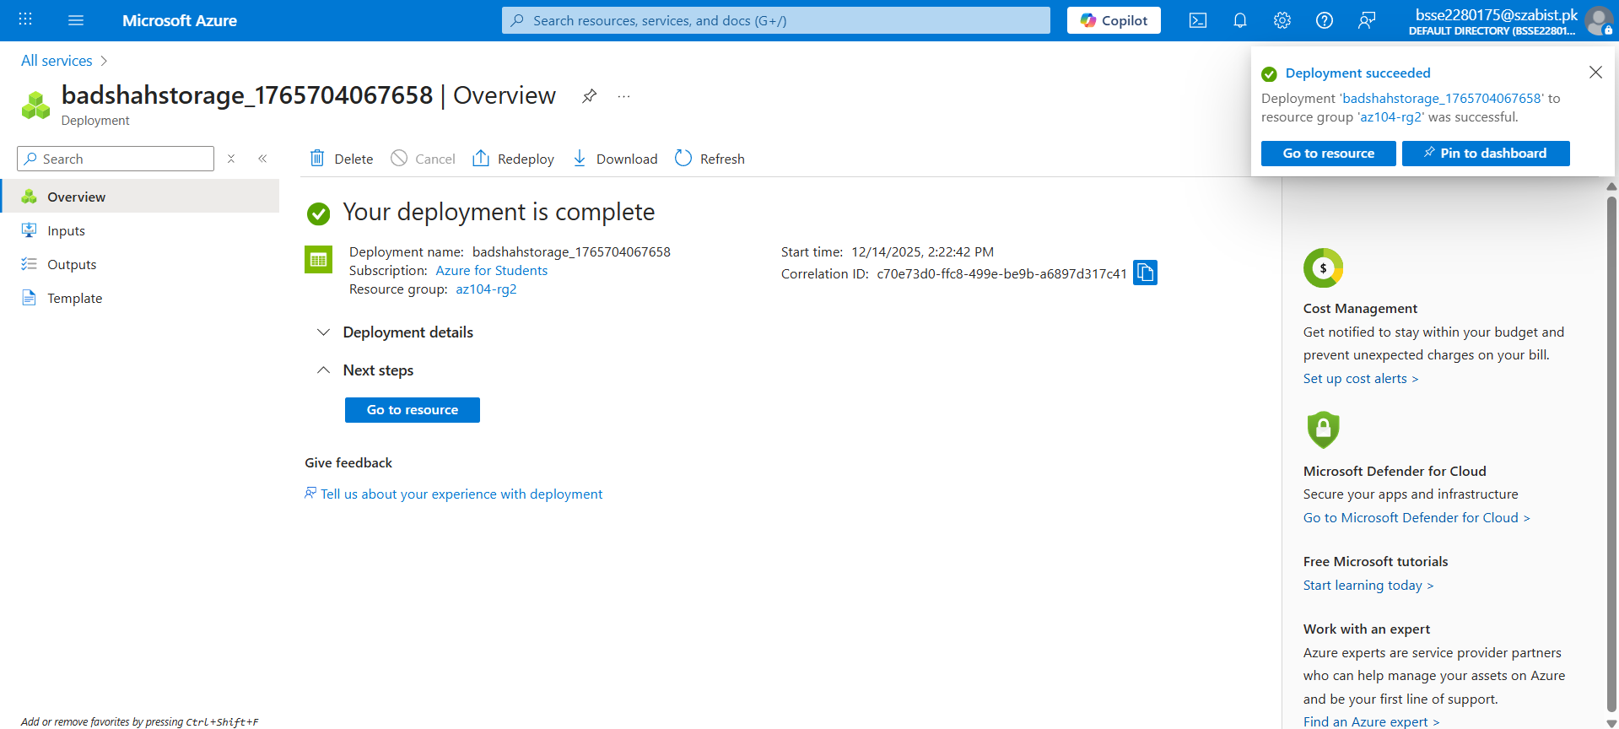
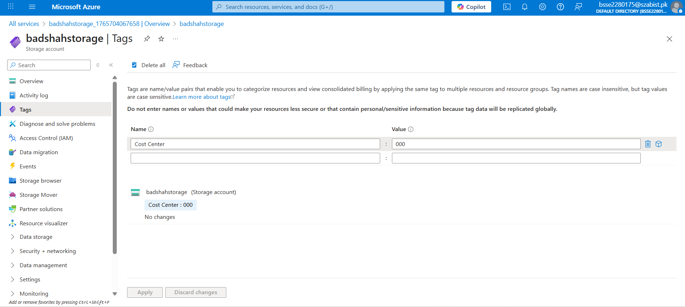
TASK 4:
RESOURCE LOCK:
